**Ideation Phase**

**Empathize & Discover**

|  |  |
| --- | --- |
| Date | 17 October 2022 |
| Team ID | PNT2022TMID16877 |
| Project Name | Project – Smart farmer – IoT Enabled Smart Farming Application. |
| Maximum Marks | 4 Marks |

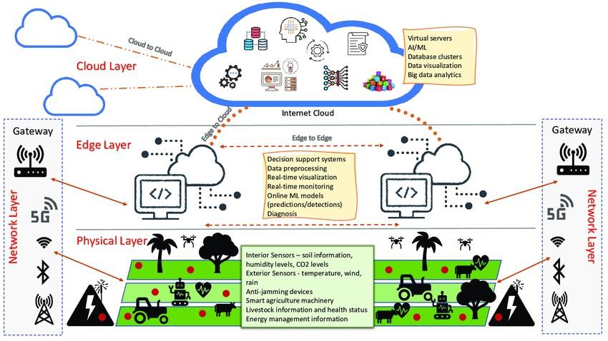

Smart farmer – IoT Enabled Smart Farming Application.